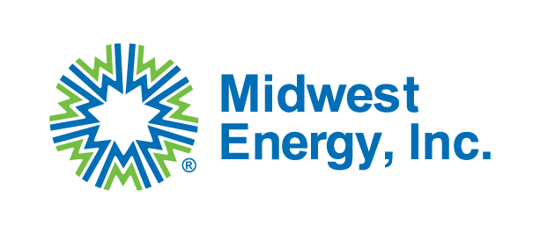
Midwest Energy, Inc.
Request for Bid
Midwest Energy, Inc. is seeking qualified distributors and/or manufacturers to provide two (2) H-Frame deadend steel structures and three (3) 50’ steel static masts for a new 115kV substation project. This project is being partially funded by the Department of Energy (DOE) through the Grid Resilience and Innovation Partnership (GRIP) program. Therefore, all steel poles must comply with the Build America, Buy America Act (BABAA) requirements set forth in Pub. L. No. 117-58, §§ 70901-52. Bidders must accept Code of Federal Regulations 2 CFR Part 200 Appendix II provisions applicable to this purchase transaction.
RFP Issue Date: 5/22/2026
H-Frame (XXXS8001-1) and Static Mast (XXXS8001-2) drawings will be posted on the Midwest Energy, Inc. website until 6/19/2026.
Sealed Bid Deadline: 5:00pm CDT on 6/26/2026
Sealed Bid Opening: 6/29/2026
Award Date: On or before 7/3/2026
All bids must be sealed in an envelope and received by 5:00pm CDT on the date listed above to:
Midwest Energy, Inc.
Attn: Purchasing Dept
1330 Canterbury Dr.
Hays, KS 67601
If you are mailing a bid packet, we ask you to expedite or overnight the package to ensure delivery by the deadline. We will not accept bids by email.
The H-Frame deadend, static mast drawings, and specifications for bidding can be found at mwenergy.com under the Community tab and the bid opportunity tab.
Link to posted documents: Bid Opportunities | Midwest Energy

Bid Requirements:
- All bids are required to be firm fixed-price and need to be submitted with unit pricing and lead times. All bids must include freight and any other additional charges.
- BABAA certifications must be submitted with the bid for the steel structures.
- Steel structures will be delivered to the address shown below.
1849 Victoria Road
Hays, KS 67601
- Midwest Energy will accept steel delivery as soon as possible.
If you have any questions, please reach out to bids@mwenergy.com.

