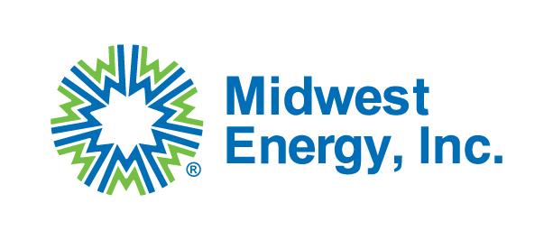
Midwest Energy, Inc.
Request for Bid Packet
Midwest Energy, Inc. is seeking qualified distributors and/or manufacturers to provide material for a 6-mile 115kV transmission line rebuild project. This 6-mile line travels predominantly from east to west from Colby to Gem in Thomas County, KS. This project is being partially funded by the Department of Energy (DOE) through the Grid Resilience and Innovation Partnership (GRIP) program. Therefore, all materials, unless approved by a waiver, must comply with the Build America, Buy America Act (BABAA) requirements set forth in Pub. L. No. 117-58, §§ 70901-52. Bidders must accept Code of Federal Regulations 2 CFR Part 200 Appendix II provisions applicable to this purchase transaction.
RFP Issue Date: 5/13/2026 Material list and instructions will be posted on the Midwest Energy, Inc. website until 5/22/2026.
Sealed Bid Deadline: 5:00pm CST on 5/27/2026
Sealed Bid Opening: 5/28/2026
Award Date: On or before 6/3/2026
All bids must be sealed in an envelope and received by 5:00pm CST on the date listed above to:
Midwest Energy, Inc.
Attn: Purchasing Dept
1330 Canterbury Dr.
Hays, KS 67601
If you are mailing a bid packet, we ask you to expedite or overnight the package to ensure delivery by the deadline. We will not accept bids by email.
The full material list for bidding can be found at mwenergy.com under the Community tab and the bid opportunity tab. Bid Opportunities | Midwest Energy
- Distributors and/or manufacturers are not required to bid the entire material list. Midwest Energy will accept bids from distributors and/or manufacturers for the material they can provide the required information for.
- All bids are required to be firm fixed-price and need to be submitted with unit pricing. All bids must include freight and any other additional charges.
- The required material list that is posted on Midwest Energy’s website has been assembled using one manufacturer per item and that manufacturer’s catalog number associated with that item. Midwest Energy believes that the manufacturer listed for each item is a source of BABAA compliant material. However, Midwest Energy will accept quotes from other manufacturers that are not on the list if the item is equivalent in design and meets the BABAA requirements.
- BABAA certifications must be submitted with the bid for all material, except for the items that are listed as having a BABA Waiver in the spreadsheet.
- Material to be received no earlier than January 4th, 2027. Project outage will begin February 15th, 2027, so we would like the material delivered before then. Material will be delivered to 1794 Country Club Drive, Colby, KS 67701 and a line contractor for Midwest Energy will be responsible for unloading material.
- Midwest Energy will accept Anchors, Insulators, Conductor, and Optical Ground Wire (OPGW) shipped directly from the manufacturer. All other material needs to be delivered from the awarded distributor. Midwest Energy requires coordinated deliveries from the awarded distributor and wants to avoid deliveries from multiple trucking companies at random times and random days of the week.
If you have any questions, please reach out to bids@mwenergy.com.

