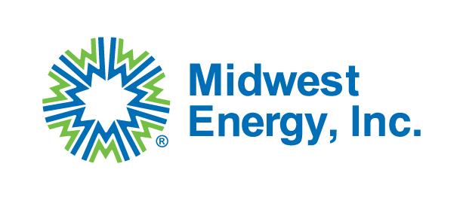
Midwest Energy, Inc.
Request for Bid Packet
Midwest Energy, Inc. is seeking qualified distributors and/or manufacturers to provide material for a 26-mile 115kV transmission line rebuild project. This 26-mile line travels predominantly from south to north from Colby to Atwood in Thomas County, KS and Rawlins County, KS one mile east of Highway 25. This project is being partially funded by the Department of Energy (DOE) through the Grid Resilience and Innovation Partnership (GRIP) program. Therefore, all materials, unless approved by a waiver, must comply with the Build America, Buy America Act (BABAA) requirements set forth in Pub. L. No. 117-58, §§ 70901-52. Bidders must accept Code of Federal Regulations 2 CFR Part 200 Appendix II provisions applicable to this purchase transaction.
RFP Issue Date: 2/25/2026 Material list and instructions will be posted on the Midwest Energy, Inc. website until 3/6/2026.
Sealed Bid Deadline: 5:00pm CST on 3/9/2026
Sealed Bid Opening: 3/10/2026
Award Date: On or before 3/13/2026
All bids must be sealed in an envelope and received by 5:00pm CST on the date listed above to:
Midwest Energy, Inc.
Attn: Purchasing Dept
1330 Canterbury Dr.
Hays, KS 67601
If you are mailing a bid packet, we ask you to expedite or overnight the package to ensure delivery by the deadline. We will not accept bids by email.
The full material list for bidding can be found at mwenergy.com under the Community tab and the bid opportunity tab. Bid Opportunities | Midwest Energy
- Poles will need to have ceramic-epoxy embedment coating cover 10% of the pole length plus 4 feet. Many of the poles are designed to be buried 10% plus 3 feet deep.
- 368 poles are tangents and will require 7-8 thru holes and 2-3 threaded holes for grounding. The remaining poles will be for H-structures, 3 pole dead ends, single pole guyed angle structures, and single pole guyed turning structures and require more holes and different patterns. Drawings to be provided after bid award.
- Poles to be received no earlier than September 1st, 2026. Project outage will begin September 28th, 2026. A line contractor for Midwest Energy will be responsible for unloading poles. Midwest Energy plans to have the delivered poles unloaded by the line contractor at pole staked locations along the line route. Laydown yard for materials and the line contractor will be at 1794 Country Club Drive, Colby, KS 67701
- All bids are required to be firm fixed-price and need to be submitted with unit pricing. All bids must include freight and any other additional charges.
- BABAA certifications must be submitted with the bid for the poles.

If you have any questions, please reach out to bids@mwenergy.com.

