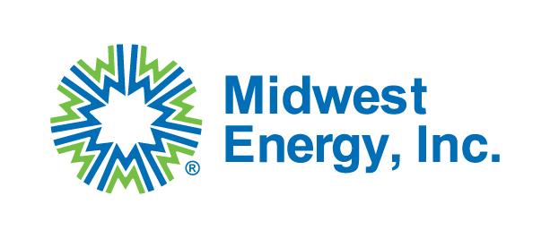
Midwest Energy, Inc.
Request for Proposal
Transmission Line Construction Contractor

Midwest Energy, Inc. is seeking a qualified transmission line construction contractor to rebuild a 25-mile 115kV transmission line in Rush and Ness Counties in west-central Kansas. This project is being partially funded by the U.S. Department of Energy (DOE) through the Grid Resilience and Innovation Partnership (GRIP) program. Therefore, the selected contractor must accept and adhere to all applicable Federal requirements including, but not limited to the Build America, Buy America Act (BABAA) requirements set forth in Pub. L. No. 117-58, §§ 70901-52 for all materials, unless approved by a waiver, Code of Federal Regulations 2 CFR Part 200 provisions, and Davis-Bacon and Related Acts applicable to labor and wages. More information is provided in the bid package regarding project scope and Federal requirements.

RFP Issue Date: 10/13/2025 Project information and instructions will be posted on the Midwest Energy, Inc. website until 10/27/2025.
Sealed Bid Deadline: 5:00pm CST on 11/4/2025
Sealed Bid Opening: 11/5/2025
Award Date: On or before 11/10/2025
All bids must be sealed in an envelope and received by 5:00pm CST on the date listed above to:
Midwest Energy, Inc.
Attn: Purchasing Dept
1330 Canterbury Dr.
Hays, KS 67601
If you are mailing a bid packet, we ask you to expedite or overnight the package to ensure delivery by the deadline. We will not accept bids by email.

A transmission line contractor project scope, construction plans, bidder qualification form, and a construction contract template including all applicable Federal requirements for bidders can be found at mwenergy.com under the Community tab and the bid opportunity tab. Bid Opportunities | Midwest Energy
- Midwest Energy will conduct a pre-bid meeting on 10/27/2025 at 1:30 PM CPT for interested bidders. This meeting will be conducted over Microsoft Teams. Interested bidders shall email bids@mwenergy.com to request a meeting invite. At this time, we will give a summary of the project and take questions from bidders.
- All bids are required to be submitted as a firm fixed price.
- Once bids are reviewed and the contractor to be awarded the project is selected, the contractor will be reviewed by DOE for approval. This may take up to 30 days, and a construction contract cannot be executed with Midwest Energy until the review is complete and the contractor is approved by DOE. The contractor may not mobilize to the site until DOE has approved contractor, and a construction contract has been executed.

If you have any questions, please reach out to bids@mwenergy.com.

