Ness City to Nekoma 115kV Transmission Line Rebuild
Proposal Information & Line Contractor Project Scope

Midwest Energy owns and operates a 115kV transmission line from Ness City substation to Nekoma substation. This 25-mile line travels west to east approximately 100’ to 200’ south of Avenue O in Rush County and 160th Road in Ness County. The Alexander substation is tapped off the existing transmission line approximately seven miles west of the Nekoma substation. The contractor selected for this project will tear down and reconstruct the line on its existing path utilizing the original right-of-way easements.

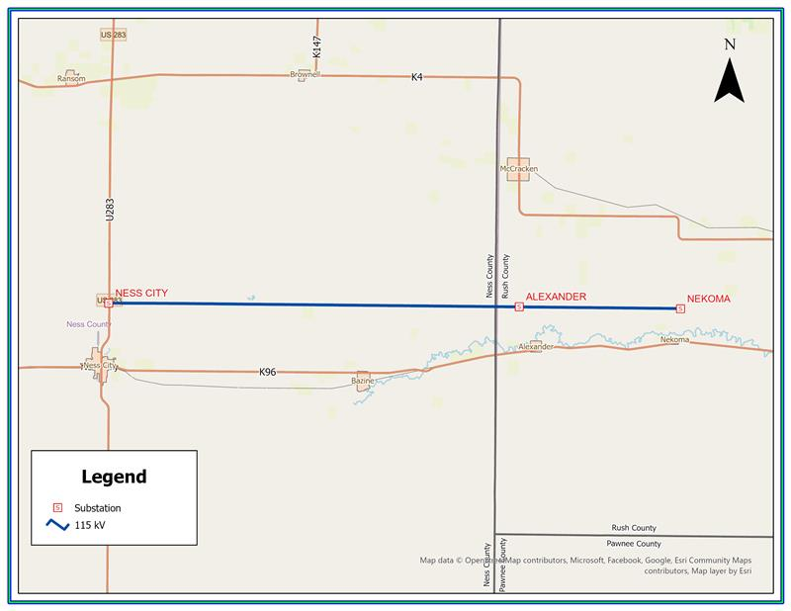
Figure 1 - Map of project area

This transmission line rebuild is partially funded through a grant from the U.S. Department of Energy Funding Opportunity Announcement (FOA) DE-FOA-2740. As such, certain Federal contract provisions will apply to the selected contractor. A construction contract template, including all applicable Federal requirements, is included with this bid package. Prospective bidders shall pay particular attention to compliance requirements for:
- Davis-Bacon and Related Acts,
- Build America, Buy America Act, and
- Code of Federal Regulations 2 CFR Part 200

Additional information on these statutory requirements is publicly available. It is the bidder’s responsibility to review, understand, and plan for compliance with all applicable Federal requirements.

Prospective bidders must provide assurance that the contractor is not a debarred or suspended entity, which precludes their ability to work on Federally funded projects. The contractor shall have a minimum of ten years’ experience in high voltage transmission line construction (115kV or above), including the installation of OPGW.

All bids submitted shall include the following:
- Fixed-firm price proposal with a proposed payment scheduled and terms to complete the identified scope of work. Note that Midwest will require 10% withholding from each invoice to be paid upon satisfactory project completion, including compliance with all Federal requirements.
- A detailed project execution plan detailing proposed approach and schedule.
- Summary of qualifications including:
  - Recent experience on similar projects
  - Key project staff (General Foreman, Foreman, project management)
  - Experience with and plan for adhering to applicable Federal requirements
- A completed pre-qualification statement (more information will be provided to bidders at the pre-bid meeting regarding this statement)

Project Information:
- Scheduled outage – January 5th, 2026 to May 15th, 2026
- Preferred project construction approach:
  - 1st Phase – 1 week duration - outage from Ness City to Nekoma to install 3-pole guyed double dead end structure (Structure #166) west of Alexander substation
  - 2nd Phase – Energize from Structure #166 east to Nekoma to keep on Alexander substation (Lane-Scott) and de-energize from structure #166 west to Ness City. Tear down and rebuild 17 miles from Ness City to Structure #166.
  - 3rd Phase – Rebuild 8 miles from structure #166 to Nekoma. Leave Alexander substation de-energized. First completing stringing from structure #166 to #178, so Alexander substation may be energized in an emergency.

- The transmission line is comprised of 247 structures – two 3-pole dead ends at the substations, two 3-pole double dead ends (#81 & #166), one 2-pole double dead end (#178), and the remaining being tangent structures. H2 class poles will be used for the dead ends, and Class 1 poles will be used for the tangent structures. There are four structures that have been replaced in recent years (#189, #201, #211 & #212), and they will remain. They are identified in the construction plan drawings. New construction includes stringing in one 3/8” EHS steel static shield wire, one optical ground wire (OPGW), and three phases of 795 ACSR (Drake) conductor. Static shield wire reels are approximately 5,000 feet, OPGW reels are approximately 22,000 feet, and 795 ACSR reels are approximately 10,000 feet.

- All transmission line structure materials and hardware shall be provided by Midwest Energy. A leased laydown area for material storage and equipment is located at 218 W Washington, Bazine KS 67516. The contactor is responsible for their own construction power at the site. Midwest Energy has three Connex boxes for storage of materials. All material will be located at the material laydown area prior to contractor mobilization, except for the poles. Poles will be dropped near structure locations based on construction staking, and it is the responsibility of the contractor to coordinate delivery of poles as the construction progresses with Bell Lumber & Pole company. Contact information to be provided by Midwest Energy.

- Landowners will be notified by Midwest Energy via letter that the awarded contractor will be contacting them to enter their property during the construction. It is the contractor’s responsibility to contact the landowners about access to each property. Negotiating crop and other land damage amounts with landowners will be the responsibility of the contractor in coordination with the manager of transmission construction for Midwest Energy. A landowner list and crop damage guidelines will be provided to the contractor by Midwest Energy.

- Line construction staking will be the responsibility of the line contractor. Staking tables are provided in the plans.

- The contractor will be responsible for any tree clearing needed for access or construction and will dispose of the trees.

- The poles and the crossarms of the truss assemblies will not be pre-drilled. The contractor will be responsible for drilling these holes during construction.

- New poles shall be backfilled with crushed aggregate (KDOT Specification 1104 Type AB-3) Aggregate to be provided by the contractor. Based on a 6” annulus around the pole, an estimate of 650 CY aggregate will be needed. This quantity may vary based on auger diameter to pole diameters. Aggregate will need to be BABA compliant, and the contractor must provide BABA certification documents to Midwest Energy.

- The contractor will need DMC Power tooling and dies for the compression dead ends and compression splices for the 795 ACSR conductor. The 3/8” shield wire will use compression dead ends and splices which will need steel hex dies (14SH). The OPGW dead ends will be bolted. All required tooling to be provided by the contractor.

- The contractor will be responsible for the splicing of the OPGW outside of substations. Expect to complete 5-7 splices based on OPGW reel lengths. Proposed splice locations shall be placed as close as possible to road crossings and shall be approved by Midwest Energy prior to construction. The splicing inside the substations will be completed by Midwest Energy personnel.

- The contractor will be responsible for disposing of the retired line structures and materials. Disposal of old material and disposal costs will be the responsibility of the contractor. Proceeds from any salvage of old materials will be kept by the contractor. Old poles will be removed in their entirety out of the ground and backfilled with dirt. There are two 3/8” EHS static wires and three 266 ACSR phase conductors to be retired.

- Excess material from this project will be the responsibility of the contractor to transport to 1794 Country Club Drive, Colby, KS 67701. Expected remaining material to include:
  - Up to 5 truss assemblies
  - Up to 10 poles
  - 3 Connex boxes, including the material inside
  - Up to 2 reels of OPGW, 4 reels of 795 ACSR conductor, and 2 reels of 3/8” EHS Steel Wire

