Colby to Atwood 115kV Transmission Line Rebuild (Task 3.0)
&
Colby to Gem Transmission Line Rebuild (Task 4.1)

Proposal Information & Line Contractor Project Scope

This project consists of rebuilding two 115kV transmission line segments in northwest Kansas. A single contractor will be selected to rebuild both line segments under a single contract starting in fall 2026 and extending into spring 2027. Additional information on each segment is provided below, and detailed construction drawing packages for each segment will be provided upon request by emailing bids@mwenergy.com.

Segment 1: Colby to Atwood
Midwest Energy owns and operates a 115kV transmission line from Colby substation to Atwood substation. This 26-mile line travels predominantly south to north in Thomas and Rawlins Counties one mile east of Highway 25. The contractor selected for this project will tear down and reconstruct the line on its existing path. See Figure 1 below.

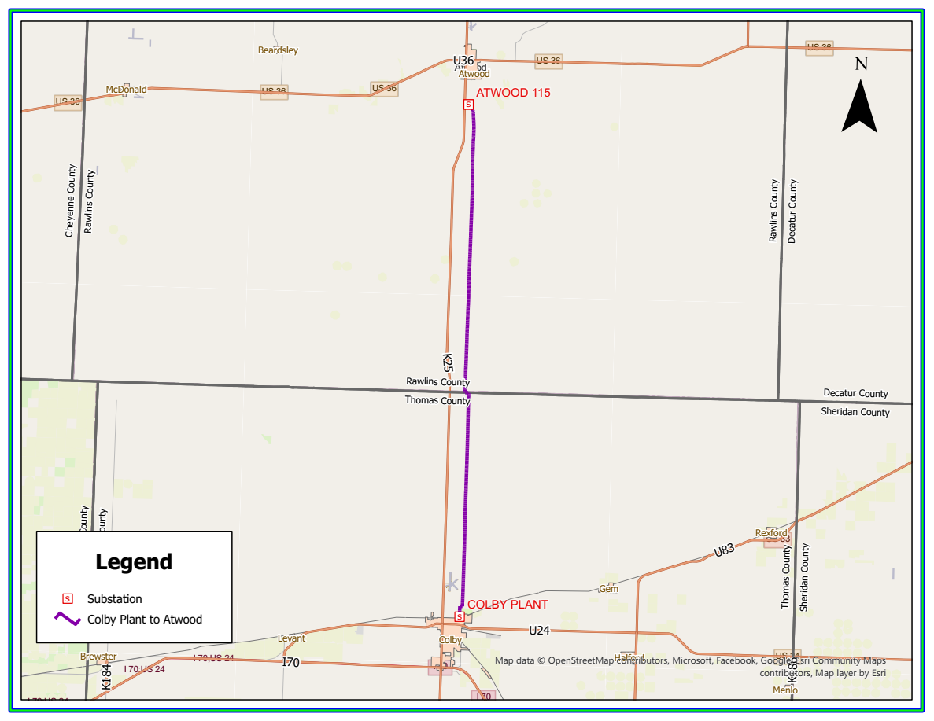
Figure 1 - Map of project area

Segment 2: Colby to Gem
Midwest Energy owns and operates a 115kV transmission line from Colby substation to GEM switching substation. This 5.75-mile line travels predominantly west to east in Thomas County and is one mile north of Highway 24. The contractor selected for this project will tear down and reconstruct the line on its existing path. See Figure 2 below.

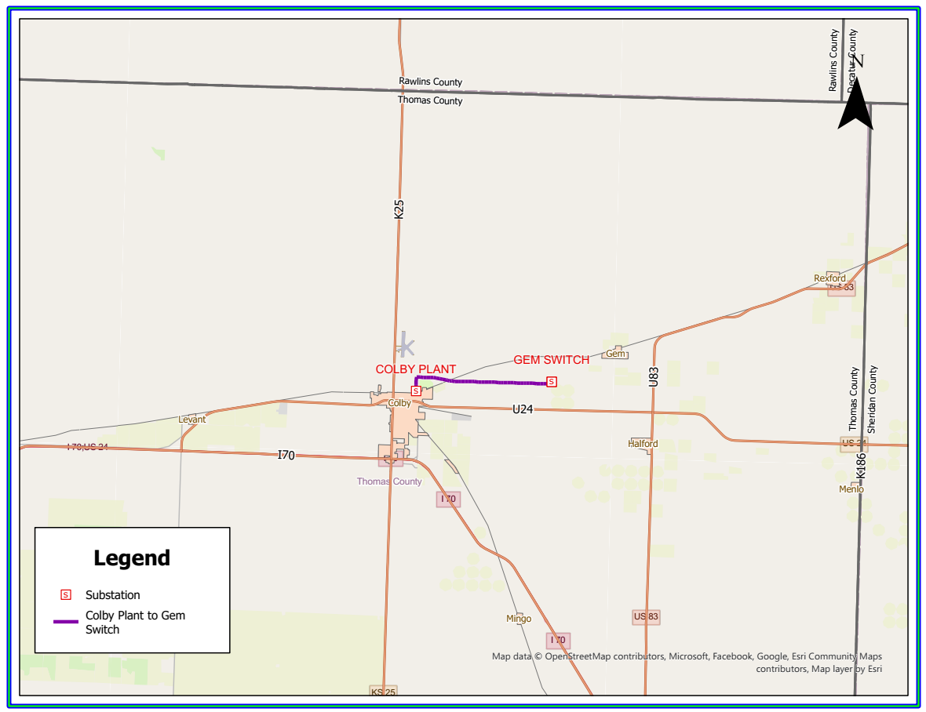

Both transmission line rebuilds are partially funded through a grant from the U.S. Department of Energy Funding Opportunity Announcement (FOA) DE-FOA-2740. As such, certain Federal contract provisions will apply to the selected contractor. The Federal award documents including applicable terms and conditions are available in the bid package which can be requested by emailing bids@mwenergy.com. All applicable Federal requirements will be flowed down to the selected contractor in the construction contract. The construction contract template, including all applicable Federal requirements will be provided to respondents prior to the pre-bid meeting for review. Prospective bidders shall pay particular attention to compliance requirements for:
- Davis-Bacon and Related Acts,
- Build America, Buy America Act, and
- Code of Federal Regulations 2 CFR Part 200

Additional information on these statutory requirements is publicly available. It is the bidder’s responsibility to review, understand, and plan for compliance with all applicable Federal requirements.

Prospective bidders must provide assurance that the contractor is not a debarred or suspended entity, which precludes their ability to work on Federally funded projects. The contractor shall have a minimum of ten years’ experience in high voltage transmission line construction (115kV or above), including the installation of OPGW.

All bids submitted shall include the following:
- Fixed-firm price proposal including:
  - Separate fixed-firm pricing for the individual Colby to Atwood and Colby to Gem transmission line segments, and
  - Proposed payment schedule and terms to complete the identified scope of work separated for Colby to Atwood and Colby to Gem transmission line segments.
- A detailed project execution plan detailing proposed approach and schedule.
- Summary of qualifications including:
  - Recent experience on similar projects
  - Key project staff (General Foreman, Foreman, project management)
  - Experience with and plan for adhering to applicable Federal requirements
- A completed pre-qualification statement (more information will be provided to bidders at the pre-bid meeting regarding this statement)

Proposal evaluation will include a review of contractor experience, qualifications and pricing. A single contract will be awarded including both Colby-Atwood and Colby-Gem construction tasks, and pricing evaluation will be based on lowest total cost for both segments. Note that Midwest Energy will require 10% withholding from each invoice to be paid upon satisfactory project completion, including compliance with all Federal requirements.

General Project Information Applicable to Both Transmission Lines:
- All transmission line structure materials and hardware shall be provided by Midwest Energy. The laydown area for material storage and equipment is located at 1794 Country Club Drive, Colby, KS 67701 (approximately 2 acres). This property is owned by Midwest Energy and will be available to the contractor for the duration of both transmission line rebuild tasks. Midwest Energy will provide a 120/240 service for construction power to an office provided by the contractor. Midwest Energy has three Connex boxes for storage of materials.

- The contractor is responsible for receiving and offloading all OPGW and conductor reels. OPGW reels are approximately 23,000 feet and 795 ACSR reels are approximately 10,000 feet.

- Landowners will be notified by Midwest Energy via letter that the awarded contractor will be contacting them to enter their property during the construction. It is the contractor’s responsibility to contact the landowners about access to each property. Negotiating crop and other land damage amounts with landowners will be the responsibility of the contractor in coordination with the Manager of Transmission Construction for Midwest Energy. A landowner list and crop damage guidelines will be provided to the contractor by Midwest Energy.

- Line construction staking will be the responsibility of the line contractor. Staking tables are provided in the plans.

- The contractor will be responsible for any tree clearing needed for access or construction and will dispose of the trees.

- New poles shall be backfilled with crushed aggregate (KDOT Specification 1104 Type AB-3) Aggregate to be provided by the contractor. Based on a 6” annulus around the pole. This quantity may vary based on auger diameter to pole diameters. Aggregate will need to be BABA compliant, and the contractor must provide BABA certification documents to Midwest Energy.

- The contractor will need presses and dies for the Hubbell (Fargo) compression dead ends and compression splices for the 795 ACSR conductor and the 3/8 EHS static shield wire. The OPGW dead ends will be bolted. All required tooling to be provided by the contractor.

- The contractor will be responsible for disposing of the retired line structures and materials. Disposal of old material and disposal costs will be the responsibility of the contractor. Proceeds from any salvage of old materials will be kept by the contractor. Old poles will be removed in their entirety out of the ground and backfilled with dirt.

- All the existing connections to the by-pass switches, CCVTs, and arresters at the substations shall be removed and reinstalled by the contractor with 795 ACSR jumper connections. Jumper conductor and hardware to be provided by Midwest Energy.

- Temporary guying and anchoring material for pulling in conductor, static wire, and OPGW is the responsibility of the contractor.
Colby to Atwood Line Information
- The existing Colby to Atwood transmission line to be removed consists primarily of single-pole wood structures with 4/0 ACSR phase conductors, porcelain suspension insulators, and 3/8” EHS static shield wire.

- Scheduled outage for Colby to Atwood – September 28th, 2026 to February 12th, 2027. The delivery of the ductile iron poles will begin at the Atwood substation and move south towards the Colby substation. The new Colby to Atwood transmission line has 413 structures, comprised of 363 ductile iron single pole tangent structures. The remaining structures are single pole turning and angle structures, two – 3 pole dead ends, two H-structure dead ends, and 2 tangent H-structures. There is also one weathered steel pole to be placed on a concrete foundation (foundation to be completed by others) – New construction includes stringing in one optical ground wire (OPGW), and three 795 ACSR (Drake) phase conductors.

- The materials will start being delivered approximately September 1st, and it will be the responsibility of the contractor to accept deliveries. The ductile iron poles for the Colby to Atwood line segment will be unloaded by the contractor along the right-of-way. Poles can be dropped near structure locations based on construction staking, and it is the responsibility of the contractor to coordinate delivery of poles as the construction progresses with McWane Poles. Contact information to be provided by Midwest Energy.

- There are 177 ductile iron poles that are 75 feet and longer and will be shipped in two pieces. They will have to be jacked together in the field and then a through bolt will be placed through the jacked together sections. This will require a hole to be drilled on each side of the pole. The ductile iron poles will be pre-drilled for most of static, insulator, and guy wire attachment points. There will be approximately 40 additional through holes that will need to be field drilled where there is X-bracing attached to H-structures and for distribution under build. The contractors should have proper drill bits for drilling through ductile iron. They can be purchased from McWane Pole or other vendors. The use of a magnetic drill when drilling these holes is highly recommended. See documents provided with the construction drawing package for information on assembly and drilling of the ductile iron poles, as well as the types of drill bits that can be used.

- The contractor will be responsible for the splicing of the OPGW outside of the substations. Expect to complete 14 OPGW splices. OPGW downlead clamps and splice boxes will be attached to the ductile iron poles using steel banding provided by Midwest Energy. The contractor is responsible for banding installation tools. The splicing inside the substations will be completed by Midwest Energy personnel.

Colby to Gem Line Information
- The existing Colby to Gem transmission line to be removed consists primarily of two-pole wood H-frame structures with 266 ACSR phase conductors, porcelain suspension insulators, and two 3/8 EHS static shield wires.

- Scheduled outage for Colby to GEM – February 15th, 2027, to April 30th, 2027 – The Colby to Gem line is comprised of 48 structures, predominantly wood H-structures, with a few 3-pole angle and turning structures – New construction includes stringing in one optical ground wire (OPGW), one 3/8” EHS Static Shield wire and three phases of 795 ACSR (Drake) conductor.

- The materials will start being delivered after January 4th, 2027, and it will be the responsibility of the contractor to accept deliveries. The wood poles for the Colby to Gem line segment will be unloaded by pole haulers along the right-of-way, with the direction of the line contractor. Poles can be dropped near structure locations based on construction staking, and it is the responsibility of the contractor to coordinate delivery of poles as the construction progresses with the wood pole manufacturer. Contact information to be provided by Midwest Energy.

- The contractor will be responsible for the splicing of the OPGW outside of the substations. Expect to complete 4 OPGW splices. OPGW downlead clamps will be attached with lag screws. The splicing inside the substations will be completed by Midwest Energy personnel.

